Customer Churn Analysis

Arafat hossain
14201023
CSE department. BRAC University
66, Mohakhali, Dhaka, Bangladesh
arafathossain847@gmail.com

Mohammad Abdul Hannan
14101161
CSE department. BRAC University
66, Mohakhali, Dhaka, Bangladesh
Mahannan102@gmail.com

Md. Maruf Rahman
14301036
CSE department. BRAC University
66, Mohakhali, Dhaka, Bangladesh
maruf.rahman95@gmail.com

Mayaz Ahmad
14101143
CSE department. BRAC University
66, Mohakhali, Dhaka, Bangladesh
charcoal548@gmail.com

Abstract
Customer churn prediction in Telecom industry is one of the most prominent research topics in recent years. It consists of identifying clients who are likely to cancel a subscription to a benefit. As of late, the versatile telecommunication market has changed from a quickly developing advertise into a state of immersion. The center of telecommunication companies has hence moved from building an expansive client base into keeping clients in house. For that reason, it is important to know which clients are likely to switch to a competitor in the close future. The information extracted from telecom industry can offer assistance analyze the reasons of customer churn and utilize that data to hold the clients. We have proposed a model for churn prediction for telecommunication companies based on machine learning techniques using Random forest classifier.

Keywords—data mining. machine learning, artificial intelligence, regression analysis, predictive analysis

Introduction
Customer churn refers to when a customer switches from one service provider to another. The focus of this paper is mainly on telecom industry because of its tremendous growth in the recent years. With easy communication and a number of service providers almost everyone today has a telecom subscription. Churn is especially important to mobile phone service providers because it is easy for a subscriber to switch services. Churn Prediction model can help analyze the historical data available with the business to find the list of customers which are at high risk to churn. This will help the telecom industry to focus on a specific group rather than using retention strategies on every customer. Individualized customer retention is difficult because businesses usually have a big customer base and cannot afford to spend much time and money for it. However, if we could predict in advance which customers are at risk of leaving, we can reduce customer retention efforts by directing them solely toward such customers.

In this paper using a telecom industry Dataset, We analyzed the customer churn which can further be used for others

Method
Basically, there are two main ways to learn about something.
1) Supervised Learning 2) Unsupervised Learning
In Supervised learning we provide an output dataset to the machine. Thus, the machine easily understands he desired outputs.
In Unsupervised learning we provide no assistance to the machine. And we make sure that the machine clusters the datasets into suitable classes.
For our project, we have used scikit-learn library. This is an open-source library with SciPy, NumPy, matplotlib built in. In data analysis, this tool is very useful. We can manipulate our data easily with regression, clustering, model selection, processing and other features of this library.
We have also used random-forest algorithm for our project. It is a learning algorithm which works on classification and regression. It takes that dataset and then creates multiple decision trees out of it and then delivers the result.
- First of all, we included necessary algorithms in our system. We imported pandas, scikit-learn, numpy and other necessary libraries into the system.
- After that we extracted the data to let them into the system. Our dataset was in CSV format, that is why we used pandas read_csv() method to extract the dataset.
- Inspecting the dataset is very important. It gives you an idea about your dataset. That is why we used head() method to look into our dataset, for example what are the columns in our dataset and so on.
- We needed to know if there is any value missing in the dataset. We needed to know about the row and column distribution. That is why used some internal methods from pandas to get a fair idea about our dataset. We used shape() method to understand the rows and we used describe() method to understand the missing data situation of our dataset.
- Dataset cleaning is very important. Success of a data science project often depends on it. There are a lot of information in a dataset which may not be important for the analysis. So, we need to delete them. For example, we do not need the area and state code information to analyses the customer churn of a telecom brand. Therefore, we must drop them.
- Now, the part comes when we select a model for our data analysis. We have used RandomForestClassifier() as our model and initiated the model into our system.
- Then we just needed to do the analyzing part. To ensure the fitting of our dataset into the model, we used fit() method. And finally, to make the prediction on our dataset we used predict() method.

RESULT
The accuracy of our model of correctly predicting churners is 95.3%. The confusion matrix and a ROC curve to dig further into the quality of our results

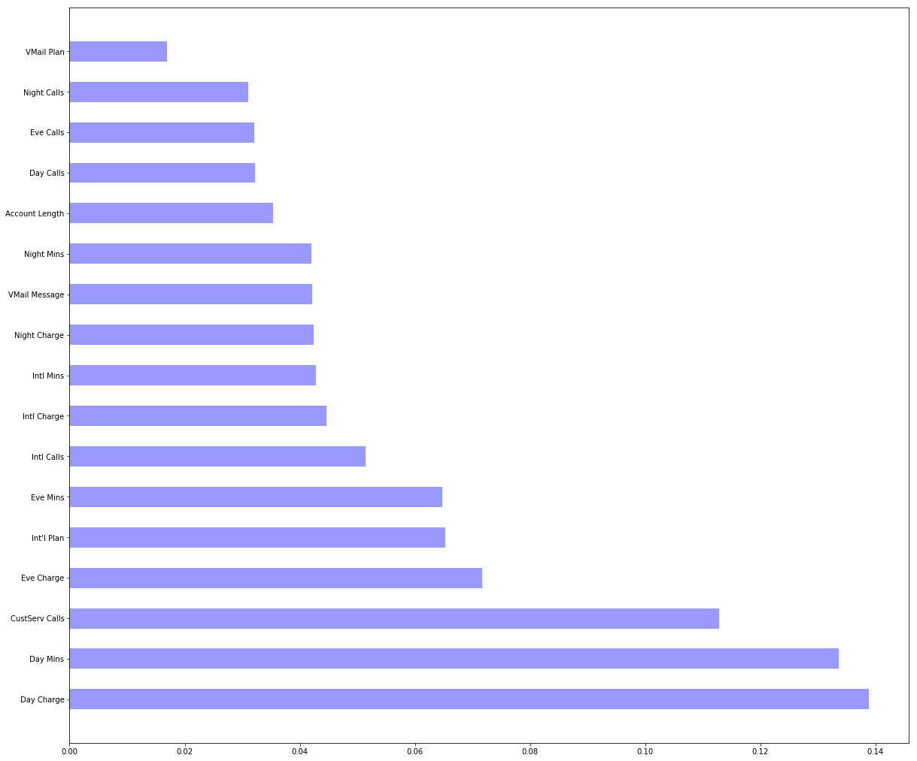

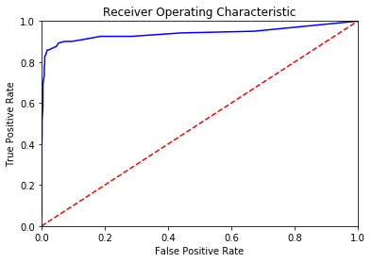

This is a more accurate and realistic version of prediction, since it shows the calculated
Possibility of a customer leaving or not, and this concept is more reliable than the yes/no version.

DISCUSSION
The approach we have used in predicting Customer Churn, although is quite cost and time efficient, however, collecting a large amount of data from large amount of customers can be quite challenging at times, and we have incorporated a very few customers in our research, whereas in actual telecom companies there are millions of subscribers. Despite of the drawbacks, we have used an efficient methodology and got realistic and reliable results, which shows Customer Churn probability and this concept would really help business authorities to identify which customers are at risk and what incentives they can implement for customer retention. A similar approach to Customer Churn is carried by a special software called Optimove which predicts which customer is likely to leave the business in the telecom industry and proved to be more efficient as it implements better methodologies than ours and the software itself points out the specific incentives required to retain at-risk customers. Despite all our drawbacks, we are trying to improve our work to compete with

conclusion
Customer churn in the telecom industry is a big loss for the authorities as replacing old with new customer is very expensive and time consuming. As a result, to help business authorities we have come up with this solution, which gives an accurate prediction of churn in the telecom industry, so that they can use the result of Churn Probability Prediction and take necessary incentives to persuade at-risk subscribers to retain their subscription.

References

1. D. V. Poel and B. Larivi. Customer attrition analysis for financial services using proportional hazard models. European Journal of Operational Research, 157(1):196{217, 2004.
2. V. Lazarov, M. Capota. Churn Prediction. Journal, Bus.Anal. Course. TUM Comput. Sci. 2007 publisher-Citeseer.
3. Shin-Yuan Hung , David C. Yen , H. Wang, Applying data mining to telecom, Expert Systems with Applications 31 (2006) 515–524, Elseiver.
4. V. Umayaparvathi, K. Iyakutti, Applications of Data Mining Techniques in Telecom Churn Prediction, International Journal of Computer Applications (0975 –8887) Volume 42– No.20, March 2012.
5. Y. Wang, D. Chlang, M. Hua Hsu, A recommender system to avoid customer churn ,”Expert System withApplication, 2009.
6. A Hybrid Churn Prediction Model in Mobile Telecommunication Industry ,Georges D. Olle Olle and Shuqin Cai ,International Journal of e-Education, e-Business, e-Management and e-Learning, Vol. 4, No. 1,February 2014.

7. Customer Churn Prediction in Telecommunication Industries using Data Mining Techniques- A Review, Kiran Dahiya and Kanika Talwar, International Journal of Advanced Research in Computer Science andSoftware Engineering, Volume 5, Issue 4, 2015.
8. Predicting Customer Churn in Mobile Telephony Industry Using Probabilistic Classifiers in Data Mining, Clement Kirui1, Li Hong, Wilson Cheruiyot and Hillary Kirui, IJCSI International Journal ofComputer Science Issues, Vol. 10, Issue 2, No 1, March 2013.
9. Analysis of Customer Churn in Mobile Industry using Data Mining, Aishwarya Churi, Mayuri Divekar, Sonal Dashpute, Prajakta Kamble, International Journal of Emerging Technology and AdvancedEngineering, Volume 5, Issue 3, March 2015.
10. A Proposed Churn Prediction Model, Essam Shaaban, Yehia Helmy,Ayman Khedr, Mona Nasr / International Journal of Engineering Research and Applications (IJERA) ,Vol. 2, Issue 4, June-July 2012.

